**JAVATEST 3 [22-07-2024]**

1. Create an ArrayList and add new elernents Lion, Tiger, Cat, Dog.

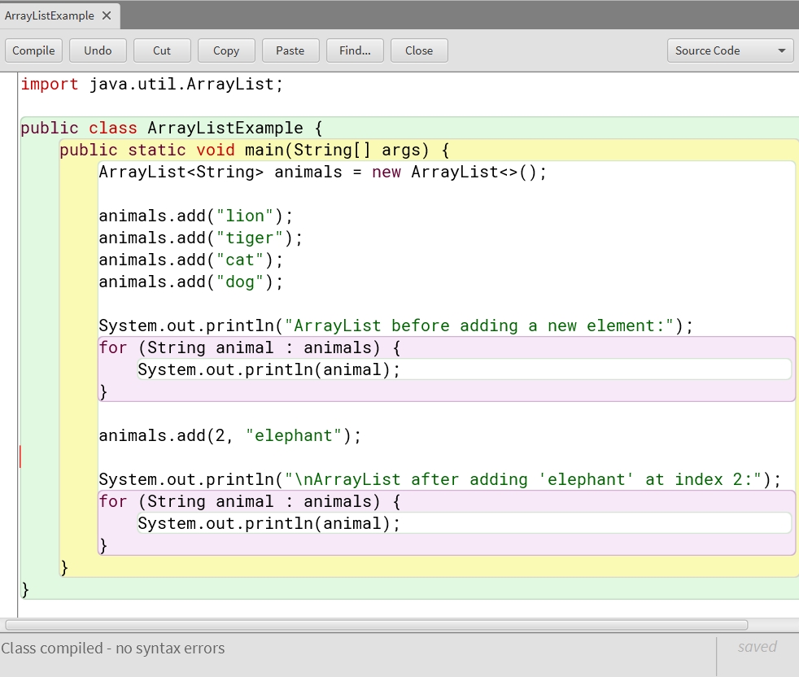

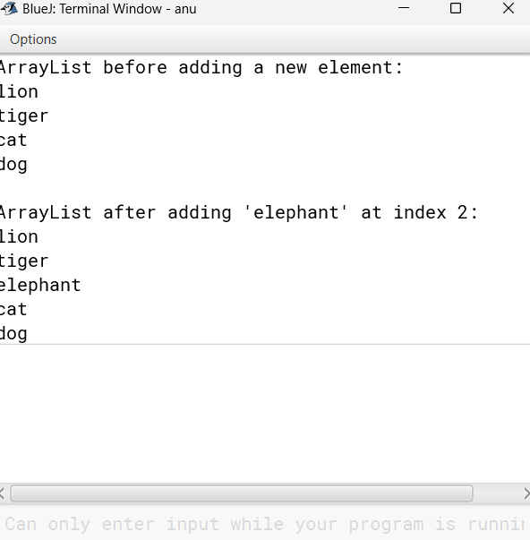

2) Create ArrayList to insert numbers 2,4,5,6,8,9. And demonstrate sizeof Arrayhist, get and set.

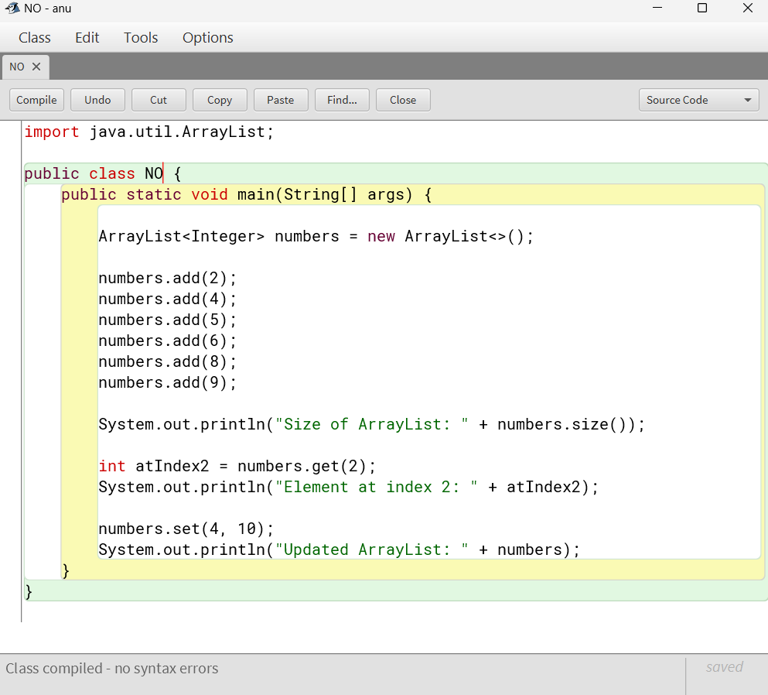

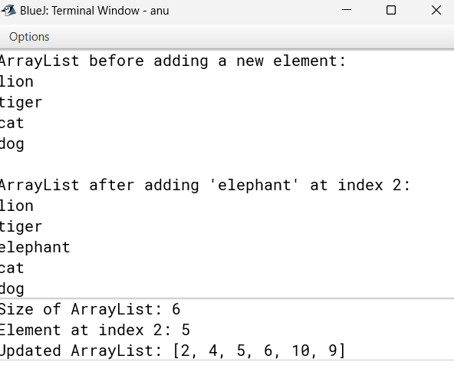

3) Create ArrayList with C, C++, Java, Python, Ruby, JanaScript Demonstrate renvone, ramoneAll, clear, remove (index)

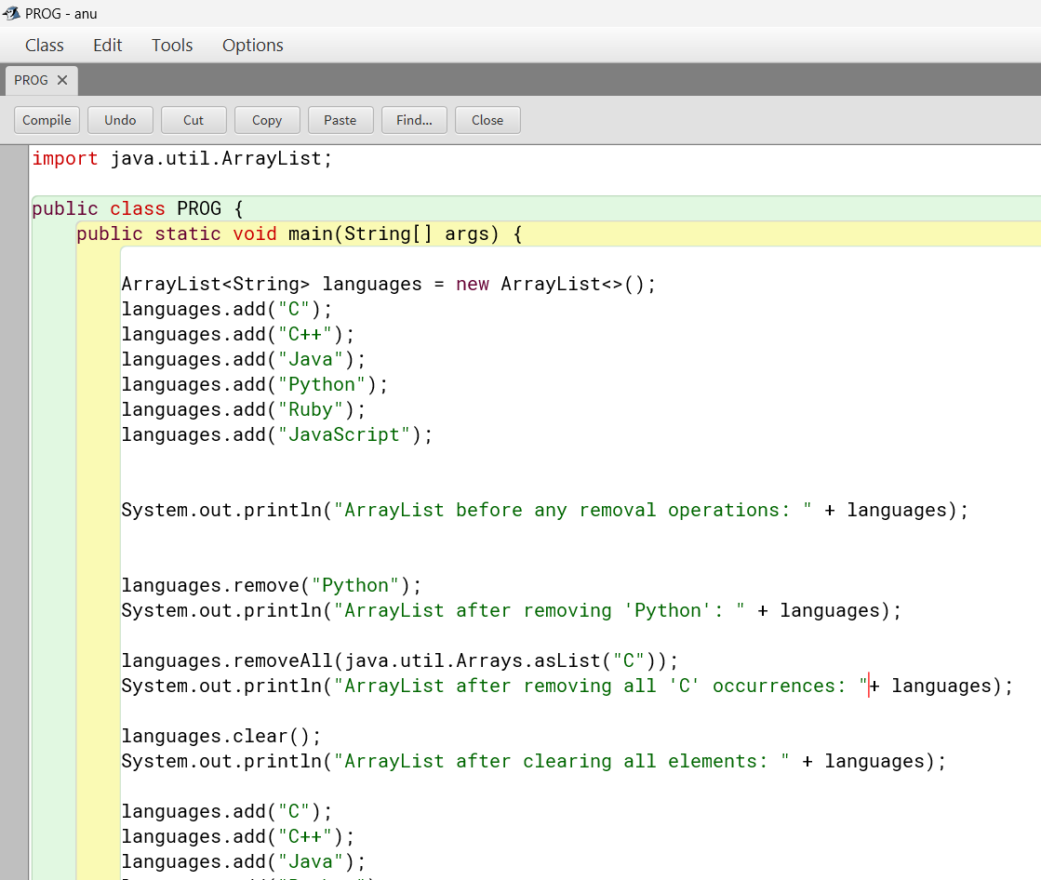

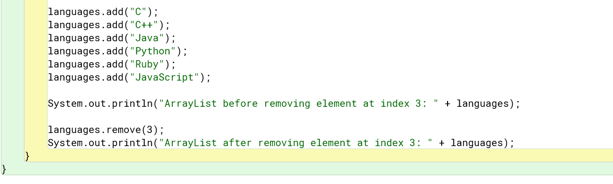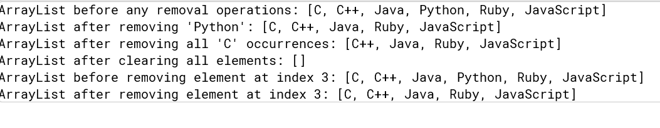

4) Create ArrayList Raja, 1, Rani, Rame, Virnal, Raja Demonstrate Iterate over At using list Iterator (). using for each, iterator()

